**Innovative Monitoring System for TeleICU Patients using Video Processing and Deep learning**

* **INTRODUCTION:**

It is proposed that the TeleICU using YOLOv8 is going to change remote patient monitoring in the ICUs. Improvisation in advanced computer vision is notably bringing a difference. With the increase in the demand for efficient health care delivery, especially in critical care settings, the program works tirelessly to enhance the responsiveness and efficiency of patient monitoring systems. YOLOv8 has been the state-of-the-art in object detection models for real-time identification and tracking of vital medical devices, activities of patients, and other clinical indicators. The TeleICU project leverages this technology embedded inside telemedicine frameworks to strengthen communication among healthcare workers in providing timely interventions. It results definitively in clearing improvements in patient outcomes and smoothening the operations in ICUs. This thus not only opens a solution toward the problems posed by traditional ICU monitoring but will also set the blueprint for telehealth in critical care in the future.

* **OBJECTIVE:**

The "Innovative Monitoring System for TeleICU Patients with Video Processing and Deep Learning" enables the handling of ICU patients through real-time video monitoring and deep learning technologies. The objectives of the work are:

* + Real-Time Monitoring: Video feeds on patients are monitored continuously.
  + Automated Detection: It makes use of deep learning for the detection of patients' behaviours.
  + Alert System: Advanced alerts on abnormal conditions to facilitate timely interventions.

These objectives, if met, will modernize ICU practices and improve patient outcomes in telemedicine.

* **METHODOLOGY:**
  + OBJECT DETETCTION: For real-time applications within the TeleICU project, fast and accurate detection methods are needed, which can be provided by YOLOv8 in the case of object detection.So we trained an object detection model using YOLOv8 for detecting three classes (patient, medical staff, family) present in any video frame or an image or real time.
  + MOTION DETECTION SYSTEM: The Motion Detection System automatically turns on when the patient is alone. At this stage, whenever there is a motion detected in the frame above the threshold value, “UNUSUAL MOVEMENT” is displayed on the frame itself.
  + API INTERFACING: Flask is a very lightweight Python web framework that allows the creation of APIs with minimum hassle. It quickly allows us to set up web services in a way that they handle requests and responses structurally.
* **TOOLS AND LIBRARIES:**
  + ULTRALYTICS ( YOLOv8 )
  + SUPERVISION
  + OPEN CV
  + HTML
  + CSS
  + ROBOFLOW
  + TENSORRT
  + GOOGLE COLAB
  + VS CODE
  + FLASK
  + PYTHON
  + GITHUB
* **RESULTS:**

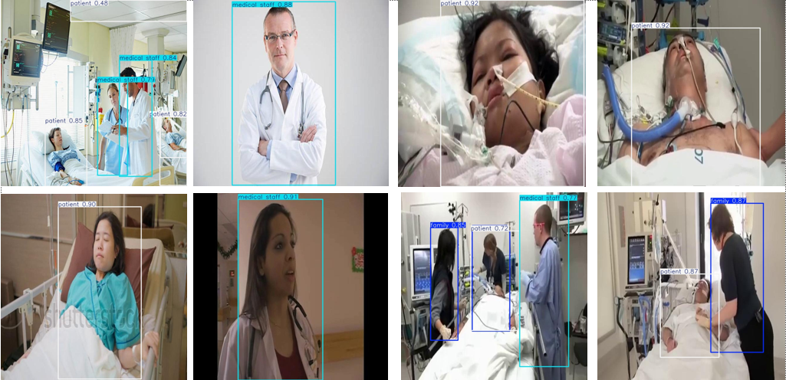

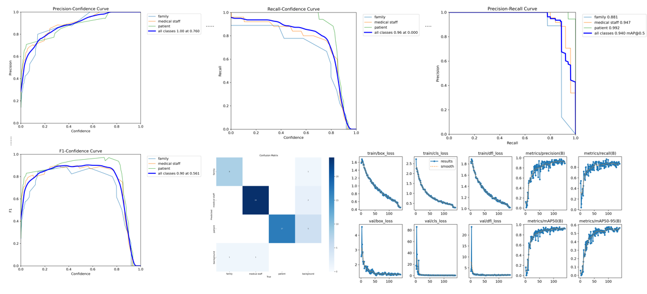

* **CONCLUSION:**

In conclusion, the YOLOv8-embedded Tele-ICU project is really an advanced version toward remote patient monitoring in critical care. In that, the project will have the ability to generate real-time object detection added to monitor patient's behavior, providing the opportunity for healthcare workers to monitor more accurately and meet the developing needs of the patients. It will lead to better outcomes and time-efficient collaboration will also be realized through the leveling of technological advancement between onsite workers and outside specialists. As telemedicine is revolutionized, the TeleICU Project opens the door to the next generation of answers for solving modern health care dilemmas, creating access to timely, efficient, quality care.